**Cyber Risk detection data review and modelling**

Detecting malicious phishing URLs.

**Dataset**

dataset.type.head()

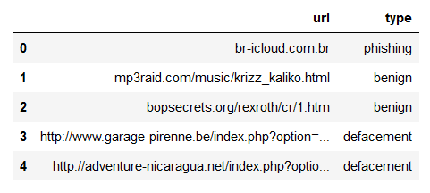

**Model suggested**  
  
Decision tree classifier was used to detect if a URL is phishing.   
  
**Model results**   
  
Accuracy about 90%.